SUBJECT- MATH CLASS-8
CHAPTER : A SQUARE AND A CUBE

DAY-1

THE LOCKER PUZZLE
Numbers follow specific rules that allow us to predict outcomes in complex situations.
- The Puzzle: Queen Ratnamanjuri left 100 lockers and a challenge: if you are the first to solve which remain open, you keep the fortune.
- The Rules: 100 people take turns; Person 1 opens all, Person 2 toggles every 2nd, Person 3 toggles every 3rd, and so on.
- The Logic: A locker stays open only if it is toggled an odd number of times.
- The Secret: Only numbers with an odd number of factors (Square Numbers) stay open.
Activity List the factors for numbers 1 to 10 and circle those with an odd number of factors.
Page Number-2 - FIGURE IT OUT

DAY-2

PERFECT SQUARES
A square number is the product of a natural number multiplied by itself.
- Notation: For any number n, we write $n ×n = n^{2}.$
- Visualizing: The area of a square is the product of its sides.
- Perfect Squares: 1, 4, 9, 16, 25... are called perfect squares.
Table of Squares Complete the squares for the first 30 natural numbers.

DAY-3

PATTERNS IN UNITS DIGITS
We can identify if a number is not a square by looking at its last digit.
- Possible Ends: All perfect squares end with 0, 1, 4, 5, 6, or 9.
- Impossible Ends: No perfect square ends with 2, 3, 7, or 8.
- Digit Pairs: If a number ends in 1 or 9, its square ends in 1. If it ends in 4 or 6, its square ends in 6.
Activity Write 5 numbers that are definitely not squares based on their units digit.

DAY-4

SQUARES AND ZEROS
Zeros in square numbers follow a strict parity rule.
- Doubling Zeros: If a number has 1 zero at the end, its square has 2.
- Even Rule: Square numbers can only have an even number of zeros at the end.
- Non-Squares: A number like 2800 (with 2 zeros) must be checked further, but 250 is definitely not a square.

DAY-5

SQUARES AND ODD NUMBERS
Every square is the sum of successive odd numbers starting from 1.
- The Pattern: $1=1^{2}, 1+3=4=2^{2}, 1+3+5=9=3^{2}.$
- Finding Squares: To find ${36}^{2}$ when ${35}^{2} = 1225$, add the 36th odd number (71) to get 1296.
- Subtracting Method: A number is a square if successively subtracting 1, 3, 5... eventually results in 0.
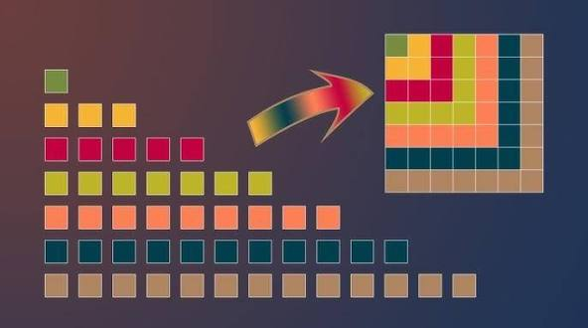

DAY-6

TRIANGULAR NUMBERS & SQUARE ROOTS
Square numbers share a deep relationship with triangular shapes.
- Triangular Numbers: 1, 3, 6, 10, 15....
- Square Link: Adding two consecutive triangular numbers gives a square number (e.g., $3+6=9$).
- Inverse Operation: Square root $\sqrt{x}$ is the inverse of squaring.
- Two Roots: Every perfect square has a positive and a negative integer square root (e.g., $\sqrt{64} =±8$).
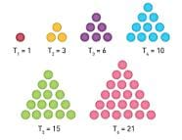
Page Number-131 – Figure it out

DAY-7

LONG DIVISION METHOD
For very large numbers where prime factorization is tedious, we use the long division method to find square roots.
- Step 1: Group digits in pairs starting from the units place.
- Step 2: Find the largest square less than or equal to the first pair.
- Step 3: Double the divisor and find the next digit to continue the division.
Activity Find the square root of 441 using the long division method.

DAY-8

PRIME FACTORIZATION & ESTIMATION
Finding roots through factors and educated guesses.
- Factor Grouping: A number is a perfect square if its prime factors can be split into two identical groups.
- Example: $324 = (2×3×3) ×(2×3×3) = {18}^{2}.$
- Estimation: To find $\sqrt{1936},$ note it is between ${40}^{2}=1600$ and ${50}^{2}=2500.$ Since it ends in 6, test 44 or 46.
Activity Find if 1156 is a perfect square using prime factorization.

DAY-9

PERFECT CUBES
A cube is a solid figure with all equal sides; its volume is the product of its side three times.
- Definition: A number obtained by multiplying a number by itself three times (e.g., $2 ×2 ×2 = 8).$
- Perfect Cubes: 1, 8, 27, 64, 125....
- Prime Factors: In a perfect cube, each prime factor appears three times or in triplets.
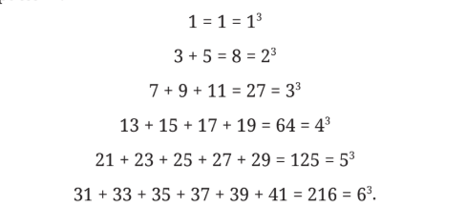

DAY-10

TAXICAB NUMBERS & HISTORY
Mathematics is filled with history and fascinating "dull" numbers.
- 1729: Known as the Hardy-Ramanujan Number.
- The Property: It is the smallest number expressible as the sum of two cubes in two different ways $(1^{3} + {12}^{3})$ and $( 9^{3} + {10}^{3}).$
- Ancient Terms: "Varga" was used for square and "Ghana" for cube in ancient Sanskrit. "Mula" (root of a plant) became the term for mathematical roots.
Activity Identify the two ways to express 4104 as a sum of two cubes.

DAY-11

CUBE ROOTS & SUCCESSIVE DIFFERENCES
The inverse of cubing is finding the cube root $\sqrt[3]{x}$
- Cube Root: If $y = x^{3}$, then $x = \sqrt[3]{y}$ (e.g., $\sqrt[3]{27} = 3).$
- Pattern Levels: For squares, differences become constant at Level 2 (always 2).
- Cube Differences: Compute differences for cubes (1, 8, 27, 64...) across levels until they become constant.
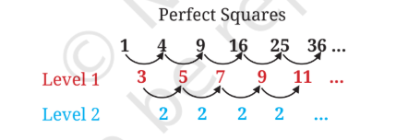

DAY-12

PUZZLES & RECAP
Reviewing properties and solving the "Square Pairs" challenge.
- Summary: Squares end in 0, 1, 4, 5, 6, 9; Cubes can end in any digit.
- Final Challenge: Arrange numbers 1 to 17 so every adjacent pair sums to a square (e.g., $15+1=16).$
Assessment
- Guess the cube root of 1331 without factorization.
- State True/False: The cube of any odd number is even.

PAGE 16
CW – Q1,Q2 ,Q4, Q5 – I,III
HW – Q3 , Q5 – II , IV
PAGE 10
CW – Q1 – I, III , Q2 , Q3 – I, III, V , Q4, Q5, Q6 , Q7 - I
HW – Q1 – II, IV , Q2 – II , IV , Q8, Q9

